Corrosion Awareness Day - Chemistry behind Corrosion

In context to Corrosion Awareness Day activities Pakistan Chapter of Association for Materials Protection and Performance (AMPP) in collaboration with Institute of Metallurgy and Materials Engineering (IMME), Faculty of Chemical and Materials Engineering, University of the Punjab, Lahore organized an event ‘Chemistry behind Corrosion’ held on March 20, 2023. Corrosion awareness day is celebrated on 24th of April every year, due to the occurrence of Holy Month of Ramadan, it was decided to conduct the activities include chemistry behind corrosion, corrosion photographic competition and technical awareness session.
The event ‘Chemistry Behind Corrosion’ was designed to develop interest and awareness about corrosion related issues and its worldwide impact on environment and assests, among the undergraduate students of B.Sc Metallurgy and Materials Engineering. To achieve this objective, Dr. Ameeq Farooq, instructor of the Applied Chemistry course, delivered introductory presentation to the undergraduate students which highlighted the basis of Electrochemistry like redox reactions, metal activity series, and displacement reactions etc. Briefly explained how the electrochemical reactions which govern the corrosion mechanism, the unique reactivity of every element and alloy in particular environment, help engineers and experts in material selection and determining the corrosion mitigation techniques. Case studies were also shared with the students to assist them to have a better understanding of corrosion related practical problems being faced in industry and their mitigation techniques. He emphasized to undergraduate students to obtain student memberships of the AMPP and Institute of Corrosion (I_{corr}). He further explained that through those memberships they will get the chance to network with the global corrosion professionals and win scholarship from international organizations. Students are encouraged to apply for AMPP and I_{corr} membership which is presently free for students.
Next a lab demonstration was conducted based on the NACE Corrosion Tool Kit (cKit) format. Different prototypes were displayed highlighting effect of corrosion in different environment, types of corrosion, corrosion clock and corrosion mitigation techniques. Demonstrators include of recently passed out graduate Muhammad Haris Qureshi and final year students Hammad Ahmed, Shahzeen Iqbal, Masooma Maqsood, Kainat, Iqra Falak Sher, Abdur Rafey Khan, Usama Sarwar and Muhammad Bilal Asghar.
Muhammad Haris Qureshi explained different types/forms of corrosion and also the different colors of corrosion like iron rust color is different as compare to rust color of copper. Hammad Ahmed briefed about the protective coatings against corrosion available for lining in aluminum soft drink cans. Shahzeen Iqbal showed the effects of different environment which includes saline, acidic, basic and industrial environments on the corrosion behavior of steel and how to mitigate the same. Masooma Maqsood and Kainat demonstrated the importance of advanced/improved materials in bio-implants to reduce the harmful impact of corrosion in human body. Biomaterials are used in biomedical (dental & orthopedic implants) applications such as bio-implants. Iqra Falak Sher demonstrated how the potential difference in an electrochemical/corrosion cell can be used to power the clock. Abdur Rafey Khan briefed about the galvanizing technique used and carried out to apply coating on mild steel samples with zinc layer. Usama Sarwar demonstrated how the potential of different alloys was measured through reference electrode and voltmeters. He also guided the students how the galvanic series was developed in the different environments to predict the behavior of the alloys. Muhammad Bilal Asghar demonstrated the nickel electroplating on the steel substrate. He further explained that in most of our daily life applications mild steel was coated with nickel like sanitary products etc. In the interactive session students raised inquisitive questions and demonstrators satisfied them by highlighting the basic principles of corrosion mechanism. This activity generated a healthy atmosphere and encouraged them to seek more knowledge.
The Director of IMME Prof. Dr. Mohsin Ali Raza was present during the session and appreciated the efforts of Dr. Ameeq Farooq and demonstrators on organizing this excellent event. At the end of the session, a quiz was conducted and top scorer was Ali Hamid, Ghulam Mehdi and Aqsa Nazeer. Prof. Dr. Mohsin Ali Raza awarded the certificate among the demonstrator of the event and the top scorer.
The other Corrosion Awareness Day activities i.e. corrosion photographic competition and technical awareness session will be held on 17th April and 2nd May, 2023 respectively.
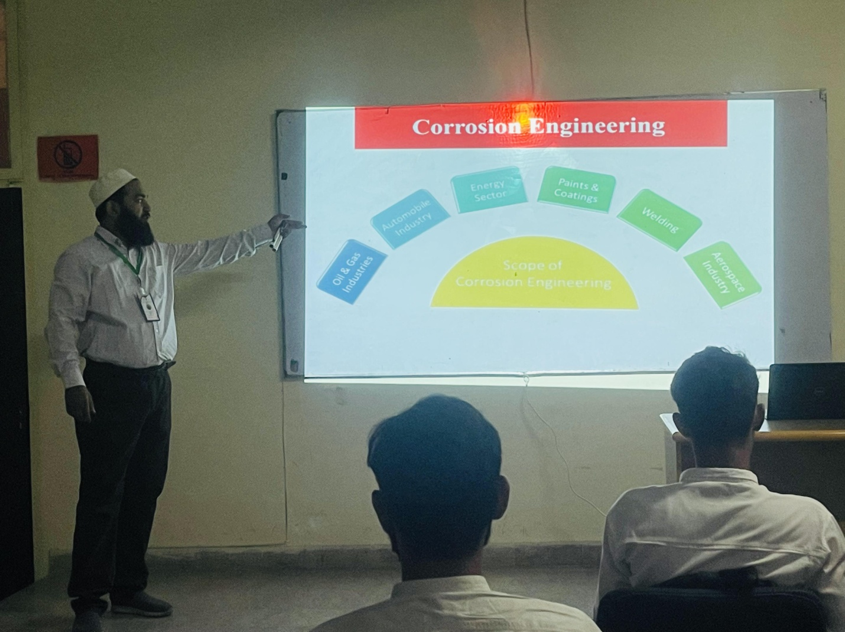
Dr. Ameeq Farooq delivering the introductory lecture
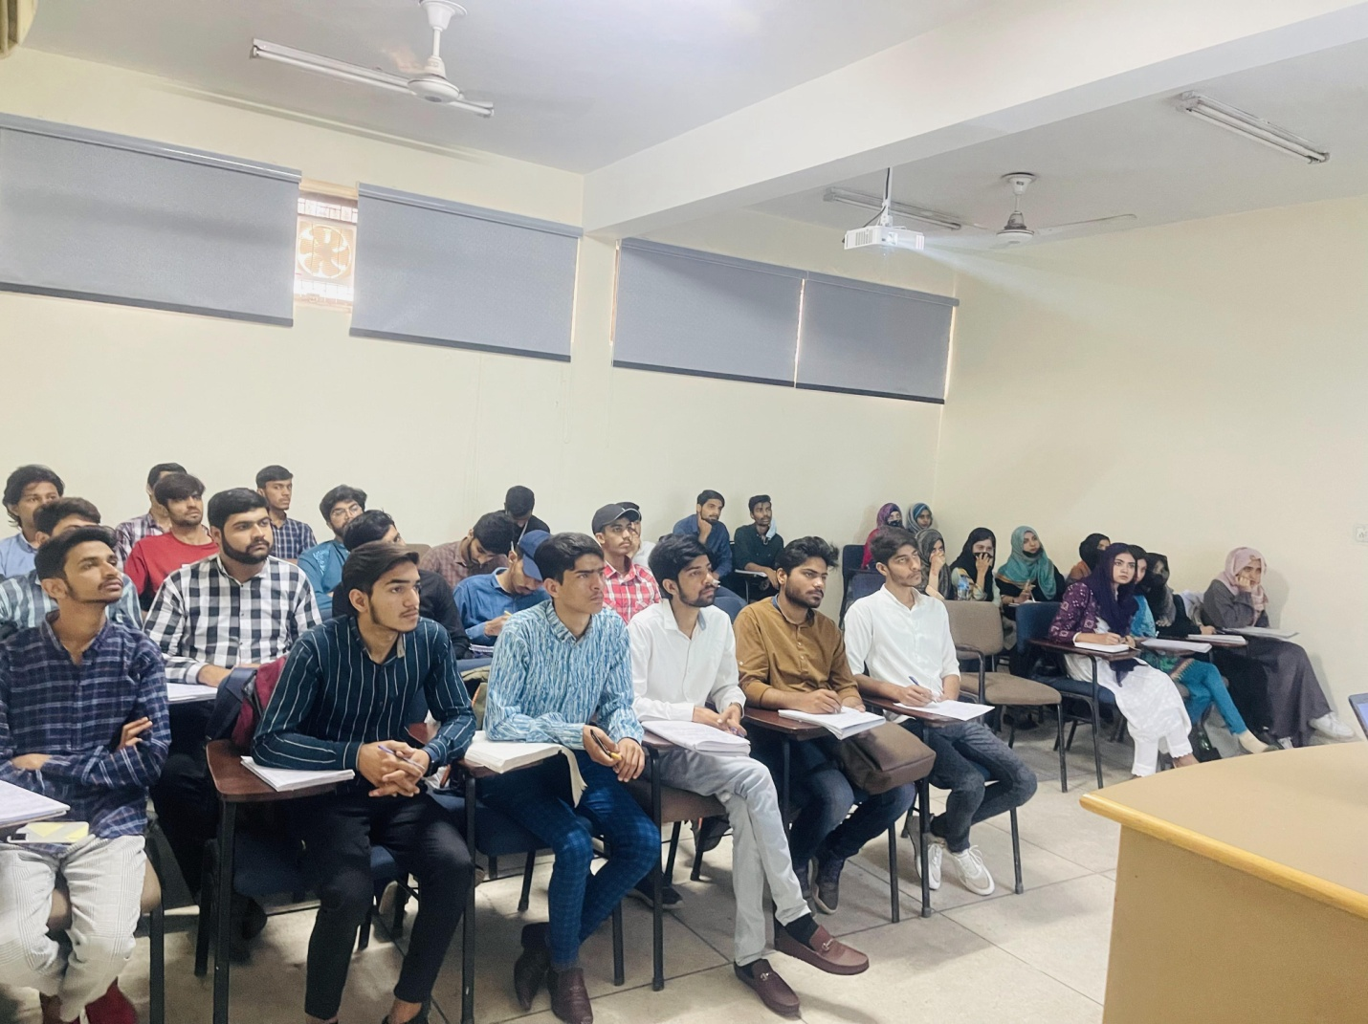
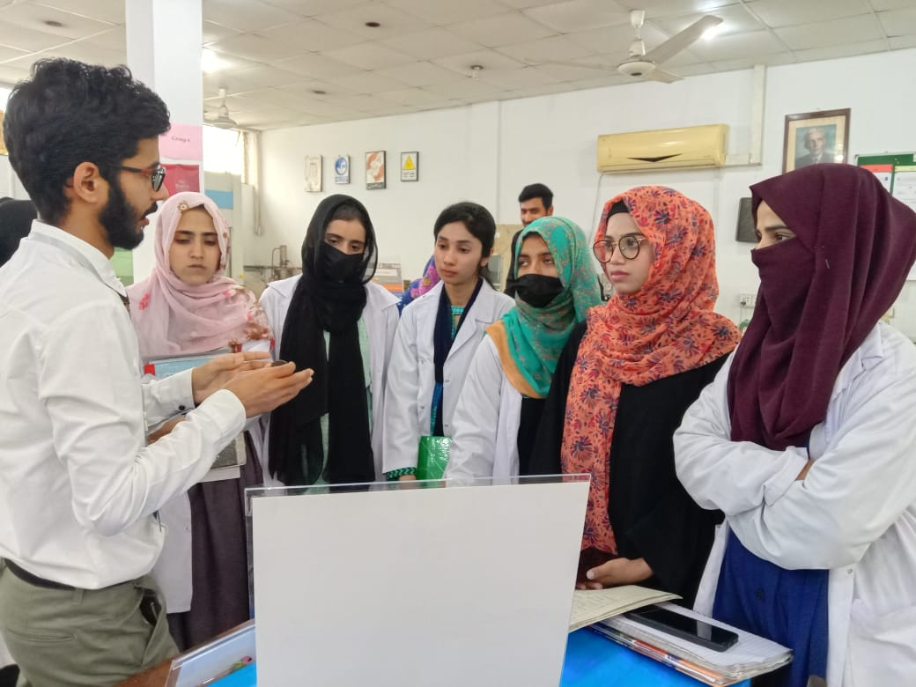
Muhammad Haris Qureshi explained about different types/forms of corrosion
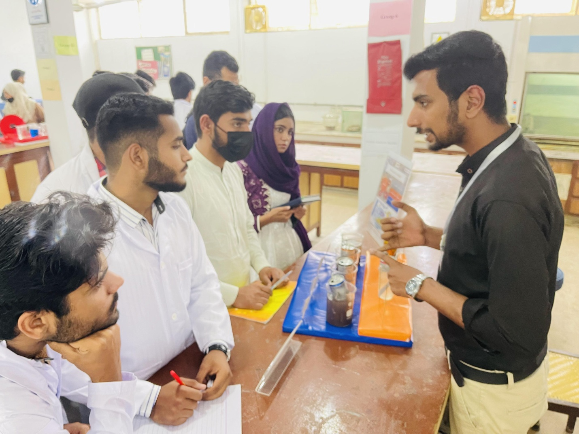
Hammad Ahmed briefed about the protective coatings applied internally on aluminum cans
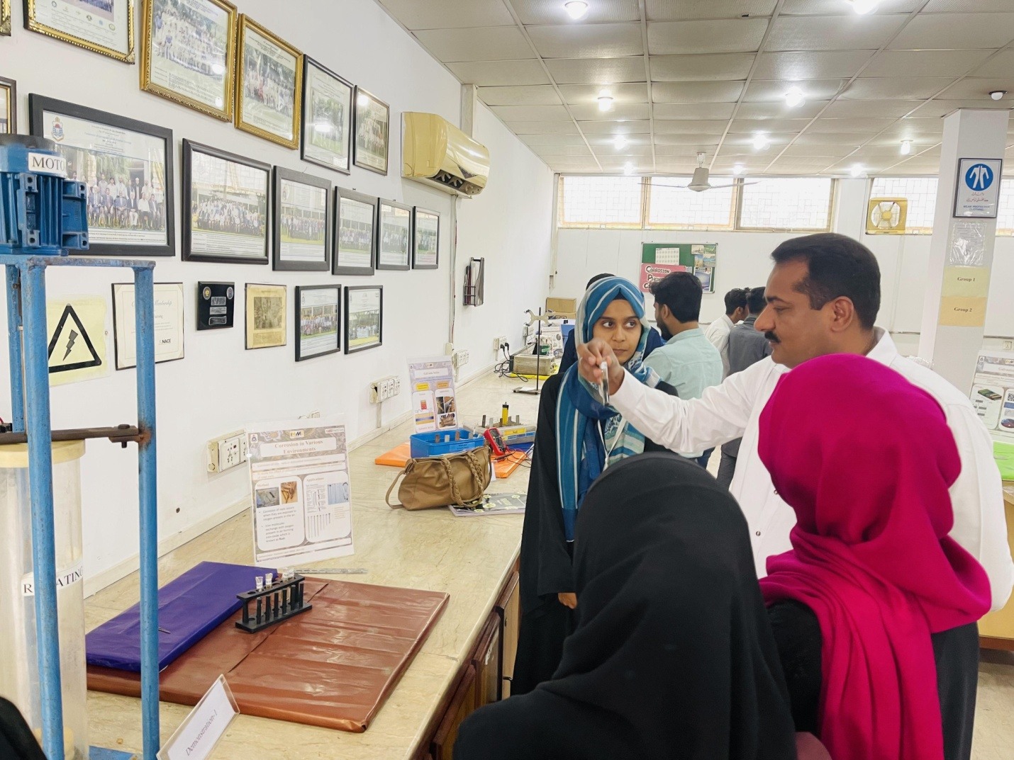
Shahzeen Iqbal briefed about the effect on corrosion due to different environment
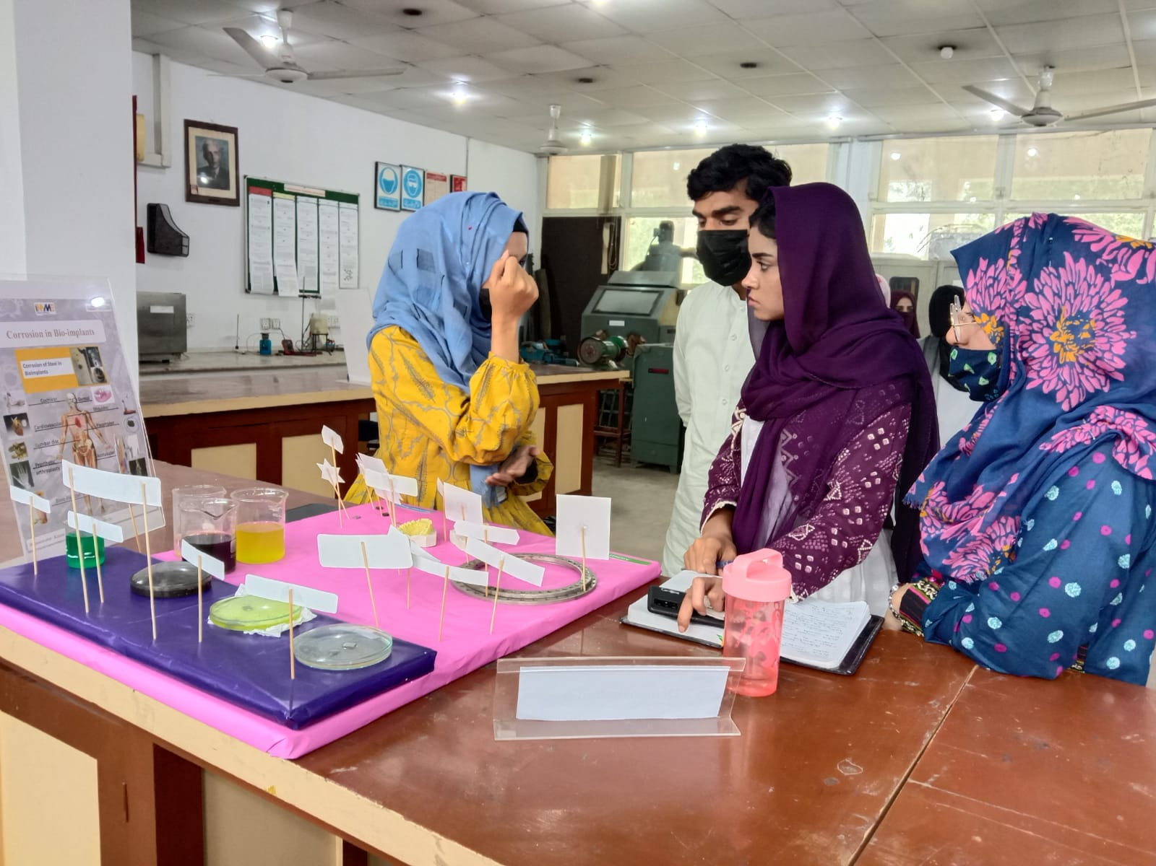
Masooma Maqsood and Kainat demonstrated the use of bio-implants in medical field
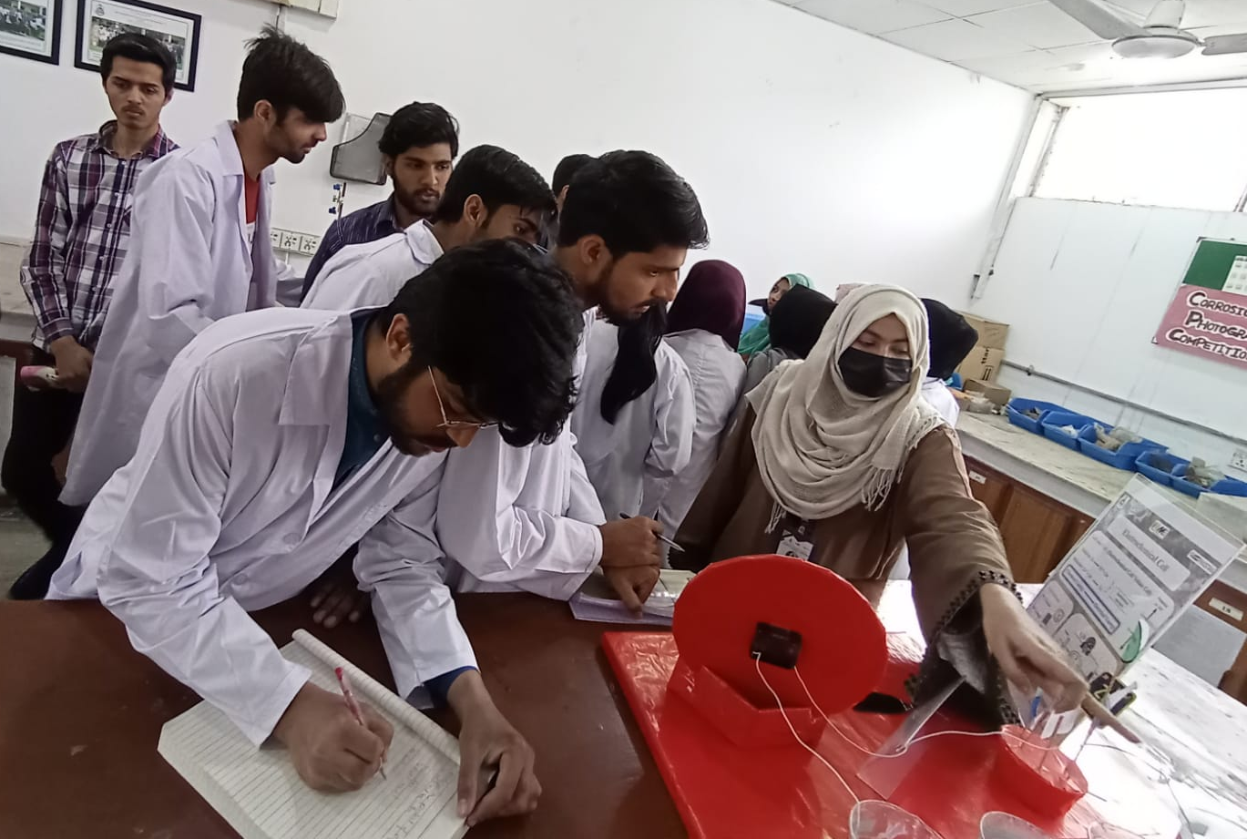
Iqra Falak Sher demonstrated the corrosion clock
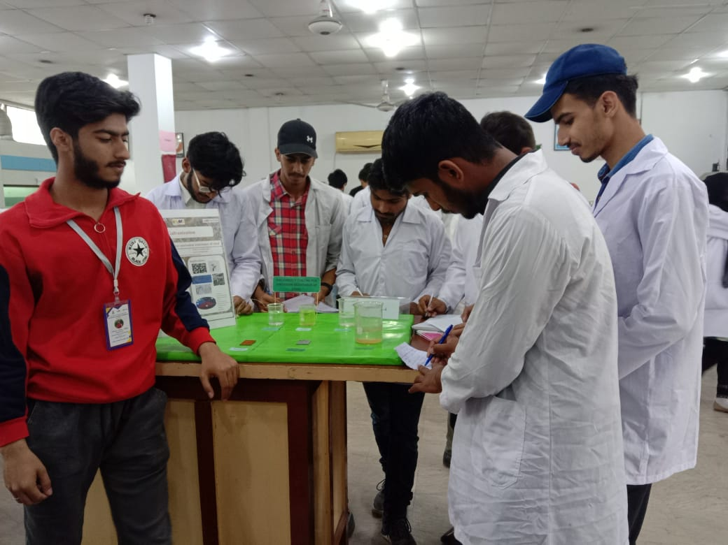
Abdur Rafey Khan briefed about the galvanizing technique
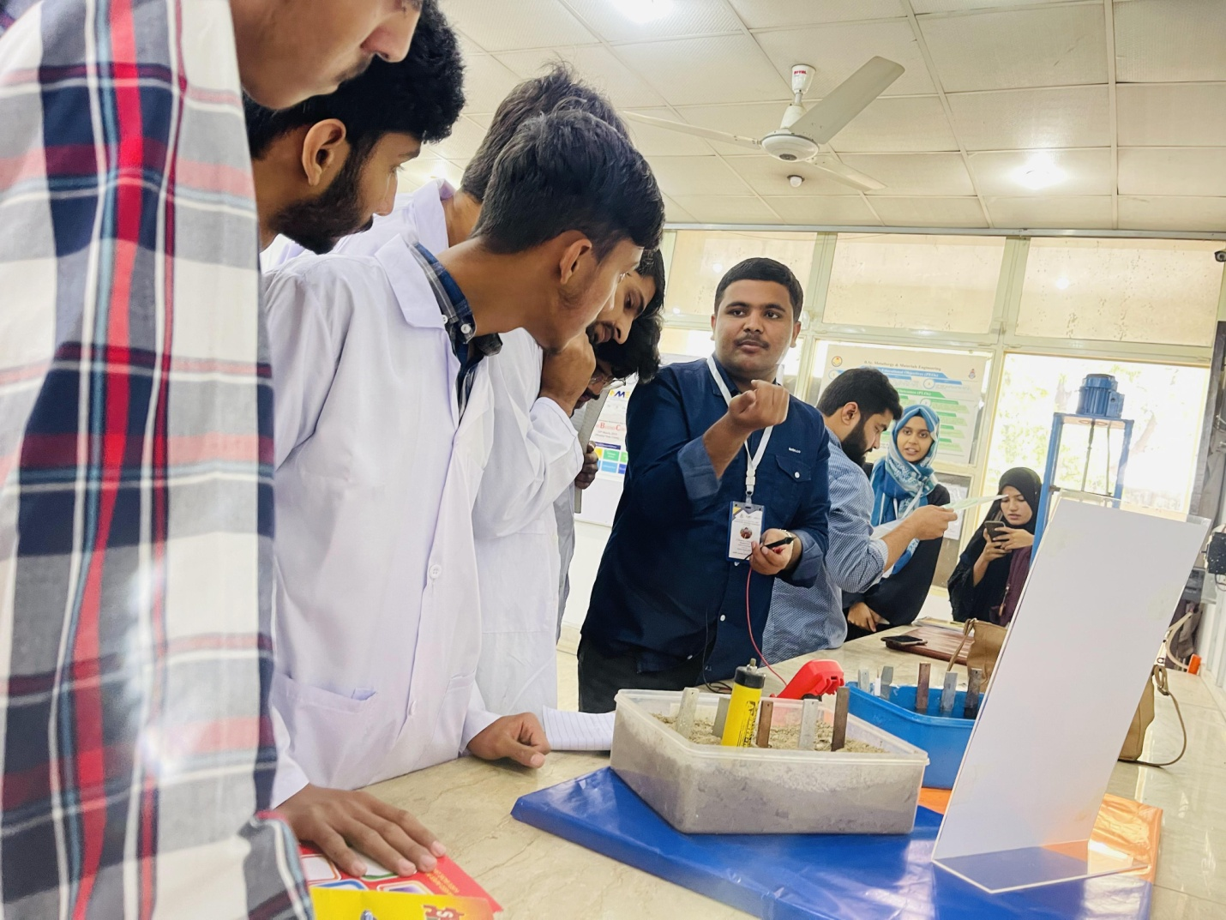
Usama Sarwar demonstrated the potential of different alloys in soil and sea water
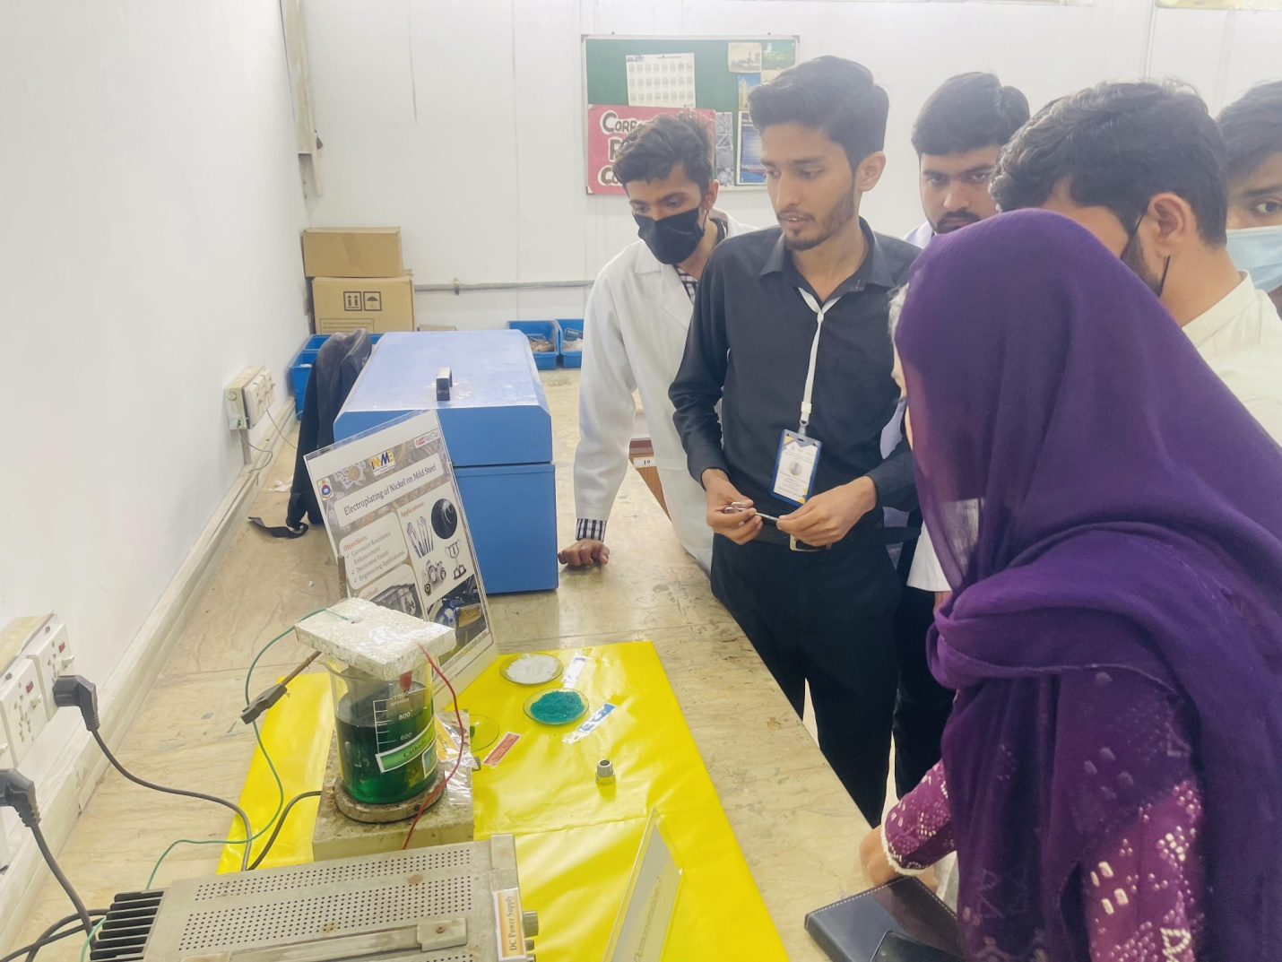
Muhammad Bilal Asghar demonstrated the nickel electroplating on the steel
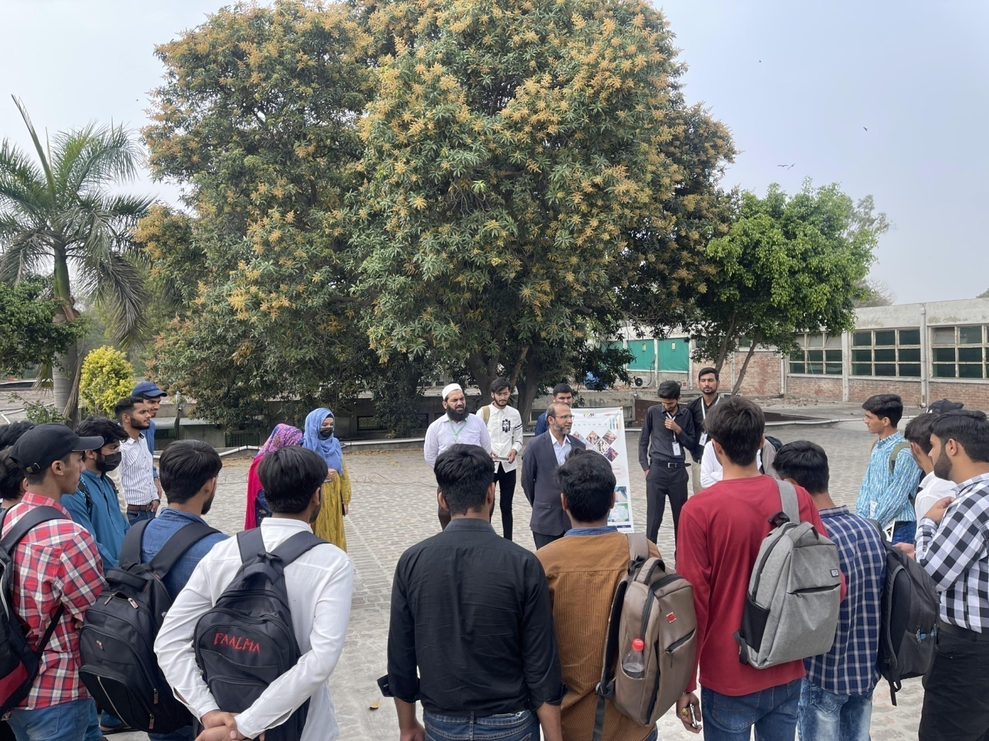
Prof. Dr. Mohsin Ali Raza interacts with the participants of the event
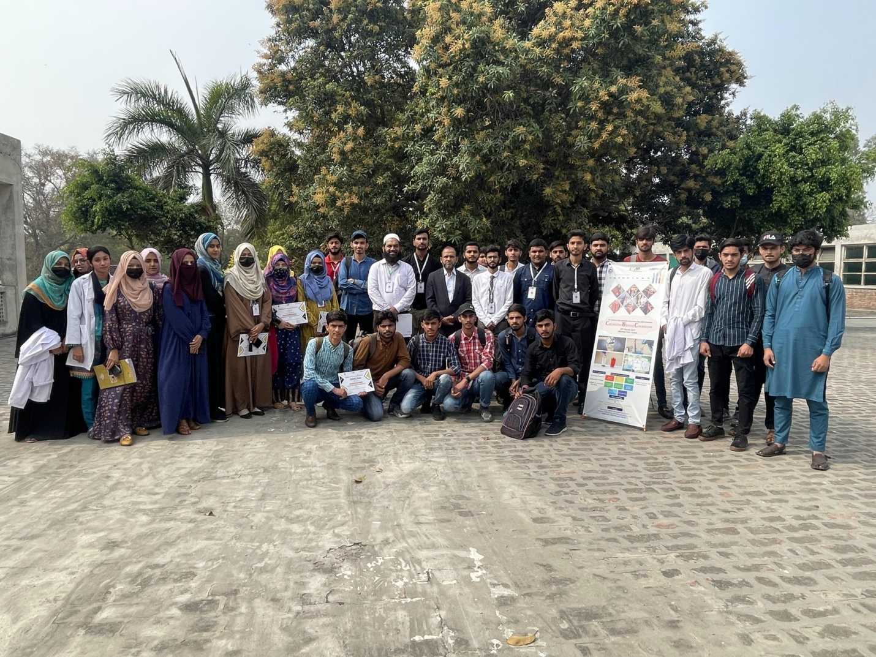
Group Photo of the event ‘Chemistry behind Corrosion’
(Author/Resource Person: Ameeq Farooq, Secretary, Pakistan Chapter AMPP & Assistant Professor, Institute of Metallurgy and Materials Engineering, University of the Punjab, Lahore)

